**Dr. Zilouchian H.W # 4 Summer 2019**

(Fuzzy Set Theory)

1. Design membership functions to describe the linguistic terms “tall”, “average”, and “short”. Justify your answer :

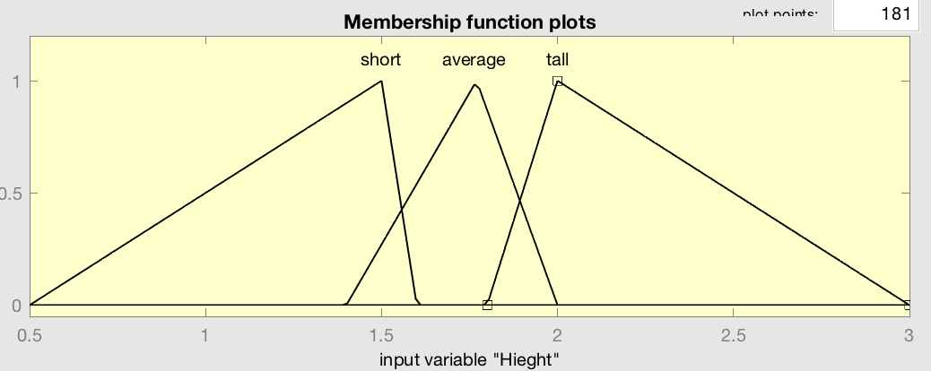

The average height of a male is 5’9” , using that as the average point I then assessed the tallest and shortest heights in history, 8’11” and ~1’. With these ranges I can assess that most people can be considered short a few deviations away from average and tall a few deviations away from average.

1. Let  and . Find the following:
2. = max[μA(x), μB(x)] = 0.5/1 + ½ + 0.2/3
3. = min[μA(x), μB(x)] = 0.3/1 + 0.6/2 + 0.2/3
4. = 1 – ( min[μA(x), μB(x)] ) = 0.7/1 + 0.4/2 + 0.8/3
5. For fuzzy sets A, B, and C defined on the universe

X={0, 1, 2, 3, 4, 5, 6, 7,8}

A={0.1/2, 0.7/3, 1/4, 0.3/5, 0.2/6}

B={0.2/1, 0.3/2, 0.6/3, 1/4, 0.7/5, 0.4/6, 0.1/7}

C={.4/2, .8/4, 1/5, .6/7, .4/8}

Answer the followings:

1. A∩B∩C =
   1. min[μA(x), μB(x)] = {0/1, 0.1/2 ,0.6/3 , ¼ ,0.3/5 , 0.2/6 , 0.1/7}
   2. min[μAB(x), μC(x)] ={0/1, 0.4/2 ,0.6/3 , 0.8/4 ,0.3/5 , 0.2/6 , 0.1/7 , 0.4/8}
   3. A∩B∩C ={0.2/1, 0.4/2 ,0.6/3 , 0.8/4 ,0.3/5 , 0.2/6 , 0.1/7 , 0.4/8}
2. A∪B∪C =
   1. max[μA(x), μB(x)] = {0/0,0.2/1,0.3/2,0.7/3,1/4,0.7/5,0.4/6,0/7,0/8}
   2. max[μAB(x), μC(x)] ={0/0,0.2/1,0.6/2,0.7/3,1/4,1/5,0.4/6 , 0.6/7 , 0.4/8}
   3. A∪B∪C ={0/0,0.2/1,0.6/2,0.7/3,1/4,1/5,0.4/6 , 0.6/7 , 0.4/8}
3. A∪B∩C
   1. A∪B = {0/0,0.2/1,0.3/2,0.7/3,1/4,0.7/5,0.4/6,0/7,0/8}
   2. A∪B∩C = min[μA+B(x), μC(x)] = {0/0,0.2/1,0.3/2,0.7/3,0.8/4,0.7/5,0.4/6,0/7,0/8}
4. Determine the intersection and union of the complements of fuzzy set B and C.
   1. ~B={1/0, 0.8/1, 0.7/2, 0.4/3, 0/4, 0.3/5, 0.6/6, 0.9/7,0/8}
   2. ~C={1/0,1/1,0.6/2,1/3, 0.2/4, 1/5, 0/6, 0.4/7, 0.6/8}
   3. ~B∪~C = {1/0,1/1,0.7/2,1/3,0.2/4,1/5,0.6/6,0.9/7,0.6/8}
   4. ~B∩~C = {1/0,0.8/1,0.6/2,0.4/3,0/4,0.3/5,0/6,0.4/7,0/8}

4. Consider two fuzzy sets  and .

Determine the fuzzy relation among these two sets. Draw the graph

|  |  |  |  |
| --- | --- | --- | --- |
|  | Y1 | Y2 | Y3 |
| X1 | 0.5/0.1 | 1/0.1 | 0.3/0.1 |
| X2 | 0.5/0.3 | 1/0.3 | 0.3/0.3 |
| X3 | 0.5/0.2 | 1/0.2 | 0.3/0.2 |
| X4 | 0.5/0.5 | 1/0.5 | 0.3/0.5 |